WallTee User’s Manual Version Oct 16, 2019

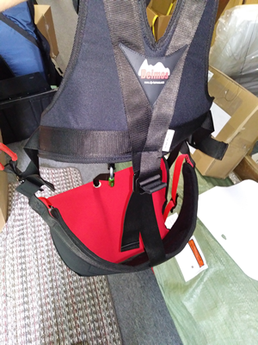 | 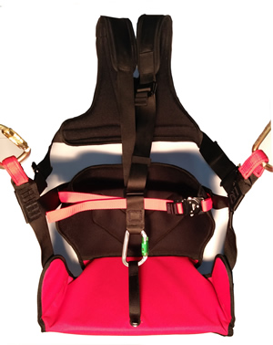 | 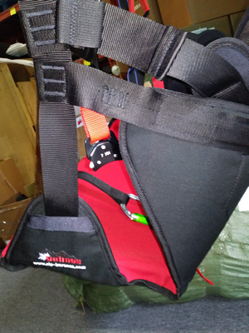

Certification:
EN1651, 12277 (for Zip lining only, not suitable for climbing)

The WallTee (S-L) harness should only be used by trained and/or otherwise competent persons or the user should be under the direct supervision of a trained and/or otherwise competent person.

Preflight Test
Before using the harness, the user should carry out a suspension test in a safe place to ensure that the harness is the correct size, has sufficient adjustment and is of an acceptable comfort level for the intended use. This is also a great time to inspect the harness for any damage.

How to put on the WallTee harness:
- Check that the shoulder carabiner is not connected to the seat board.
- Loosen/ release all straps.
- Put shoulders straps on first and connect the seat board carabiner (has a green key lock gate), then tighten until snug.
- Connect the waist strap until snug.
- Adjust the side black Deimos buckle to the preferred riders angle desired for maximum comfort.
Sizing
(XS- S) Riders age 2-11 (coming soon).
(S-L) Riders age 8 and up (minimum 30kg maximum 120kg)
(L-XXL) For Riders 220 to 300 lbs (coming soon).

Adjustments
Both the shoulder and waist straps must have a snug fit.

WallTee Hard Points (see picture below)
Both (green) locations must used to secure the rider to the trolley system. Aluminum carabiners are not recommended due to small stresses of 300 kg or more that could eventually could lead to full carabiner failure - (45kN steel carabiners with securing pins are recommended).
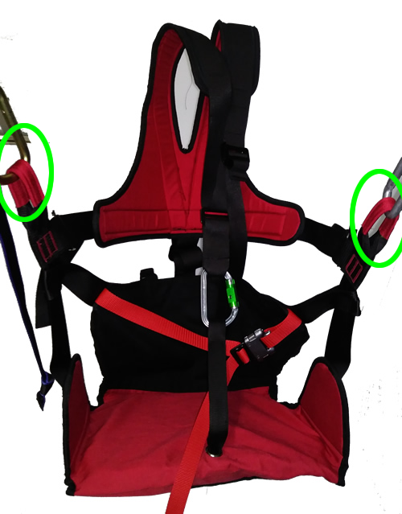

Safety
All riders must maintain an upright position (if the riders inverts, although difficult, they may be able to fall out of the harness). After each fall or impact the harness must be fully inspected for any damage, this includes times when the harness may come in contact with any corrosive chemicals. Recheck all buckles before connecting to the trolley system. During normal use they may loosen up.

This harness cannot be used as a fall arrest harness.

Lifespan
Each harness has been designed to operate for up to a maximum of ten years (if undamaged), however a single fall or exposure to harsh chemicals may require that the harness be retired immediately. Pitted rust on any of the metal parts will require the harness to be retired. Once the protective red material on the hard points have been damaged and the black webbing is now exposed, then the harness must be retired.

Transportation and Storage
Mold can start to grow on the webbing if left wet. Harnesses should be stored away from sunlight and in a cool dry location. For transportation they should be in a plastic bag.
If mold is discovered on the harness then it must be retired.

Sand, Ice and Snow
In rare occasions, a grain of sand, ice or snow can prevent the waist buckles for locking fully. They should be tested prior to using.

Please contact Deimos Zip Harness if you have any questions.

